About Hacking Club
Hacking Club is a platform to learn cybersecurity, an incredible resource if you don’t know where to start. In addition to vulnerable machines, you have access to classes and challenges to practice your skills and access to an exclusive community to play and challenge yourself.

The best part about Hacking Club is that it is very hands-on. If you are new to hacking, give it a try.

Introduction
This write-up refers to the Horizont machine.If you require support, please open a ticket in the support channel on the Discord server.

Write-Up
nmap 10.9.2.10 -A -Pn -p- --min-rate 2000 -vvv

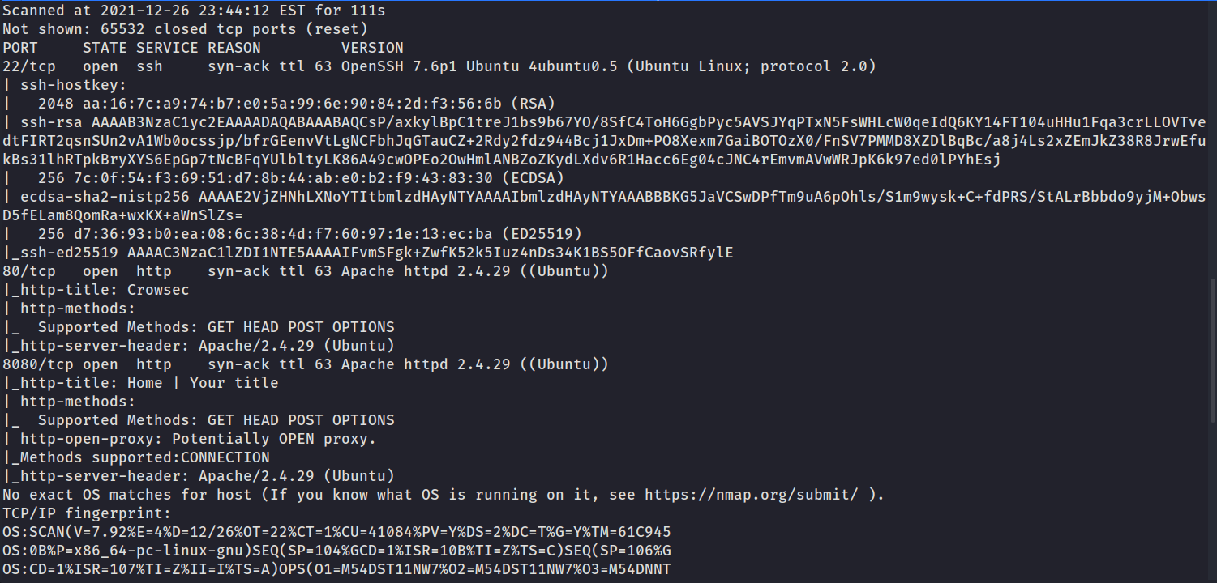

Web Application:
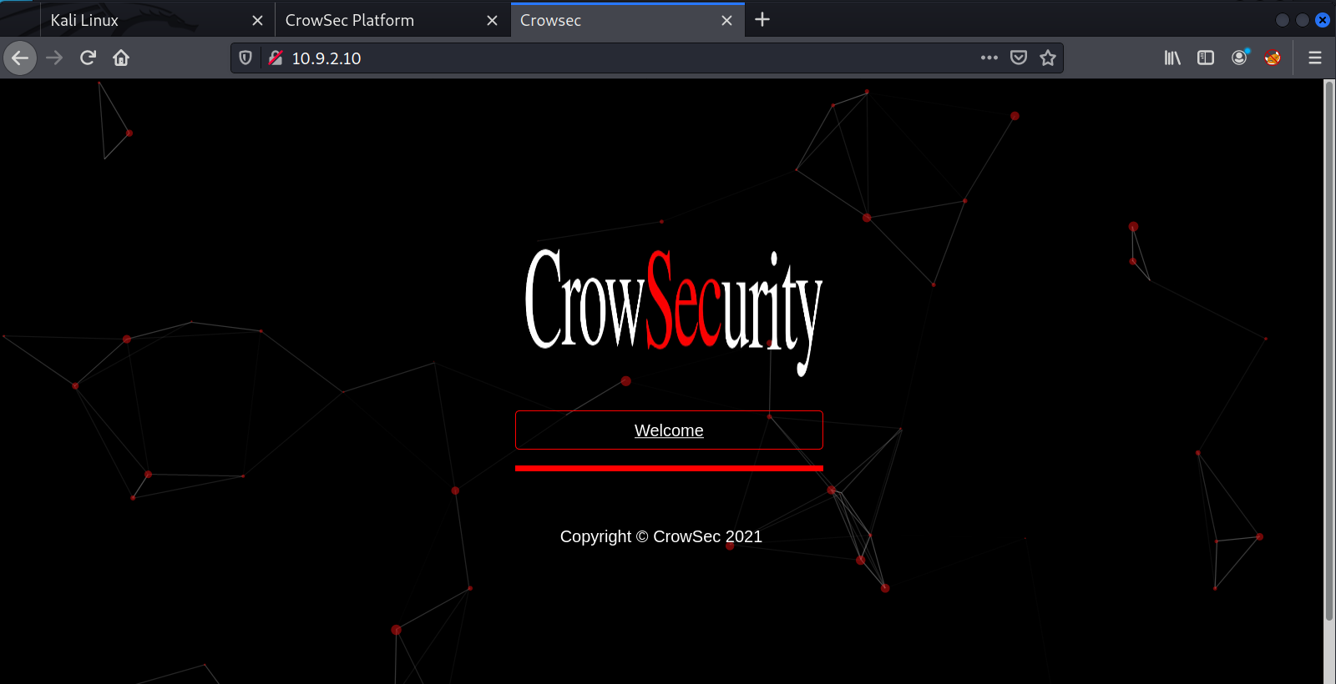
Analyzing the page source code, we found an HTML comment.
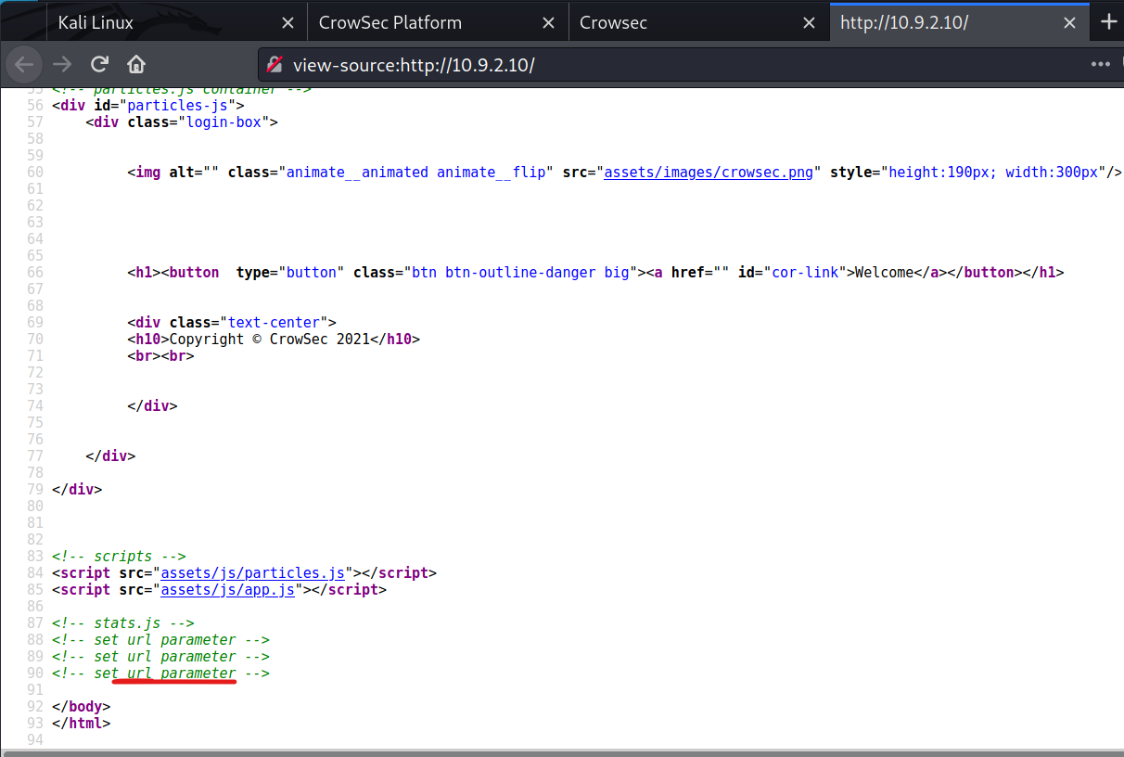
By passing the parameter /index.php?url=Vwe noticed that it was vulnerable to SSRF.

Reading AWS Metadata
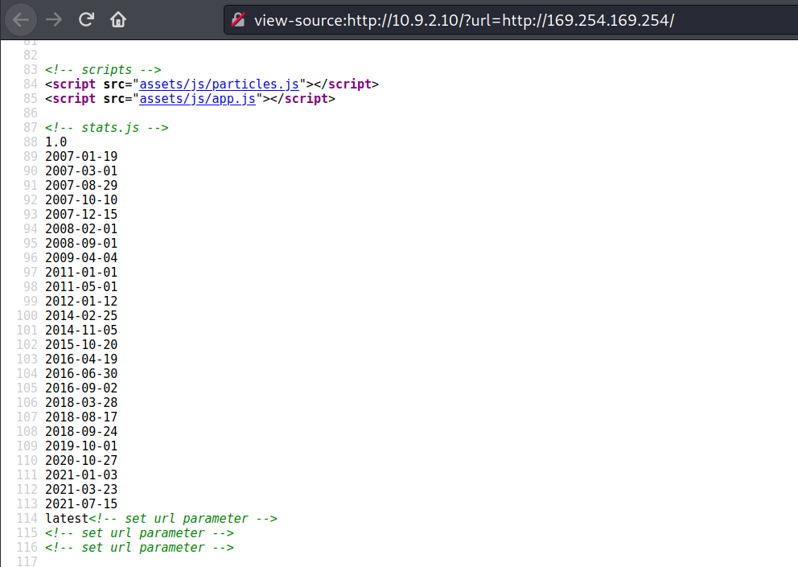
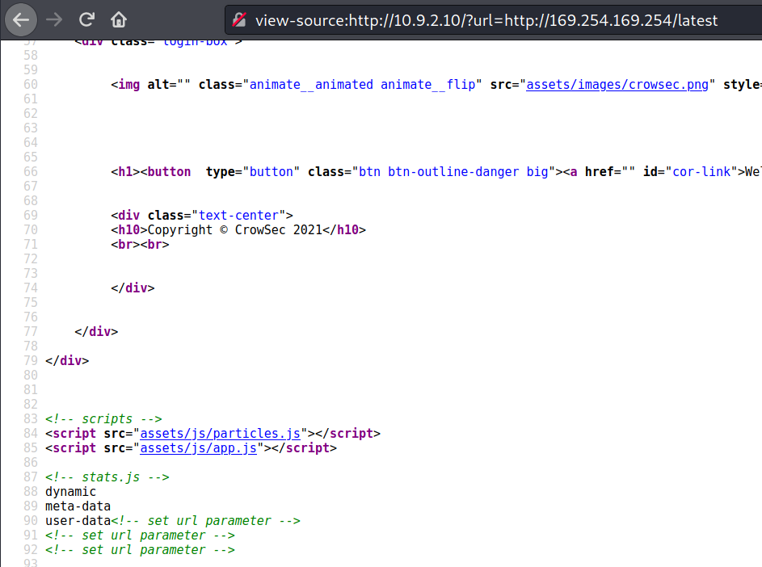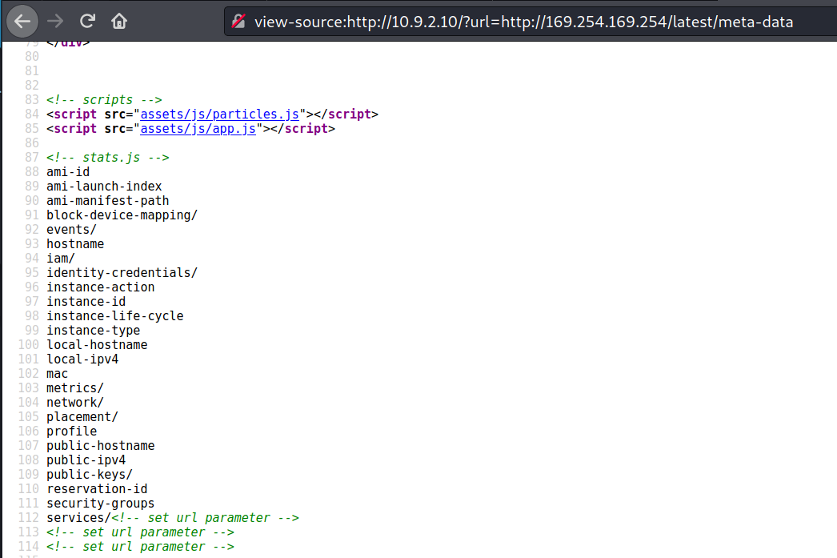
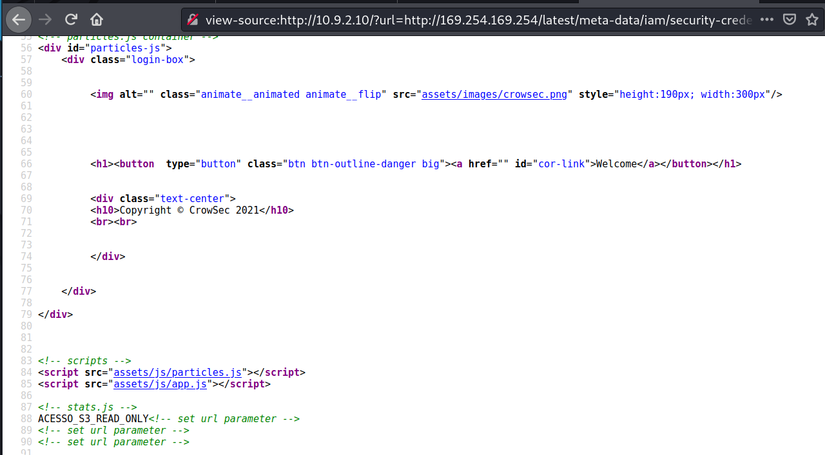

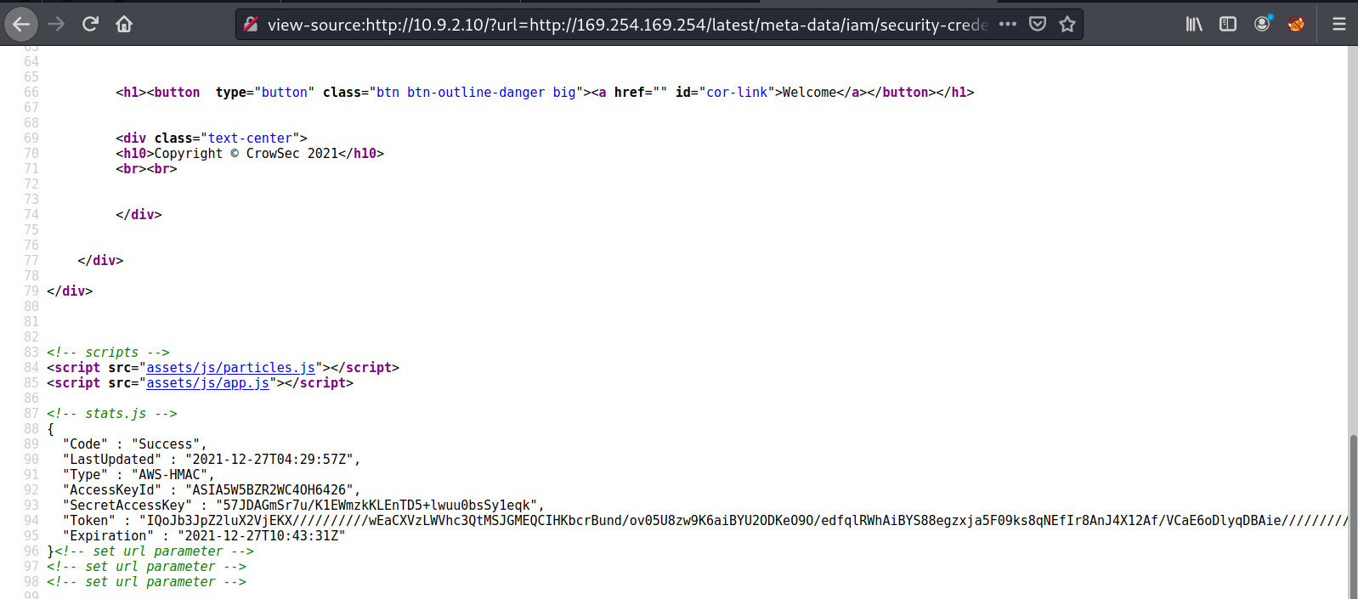
With the token and all other required data in hand, we used the PACU tool to log into AWS.
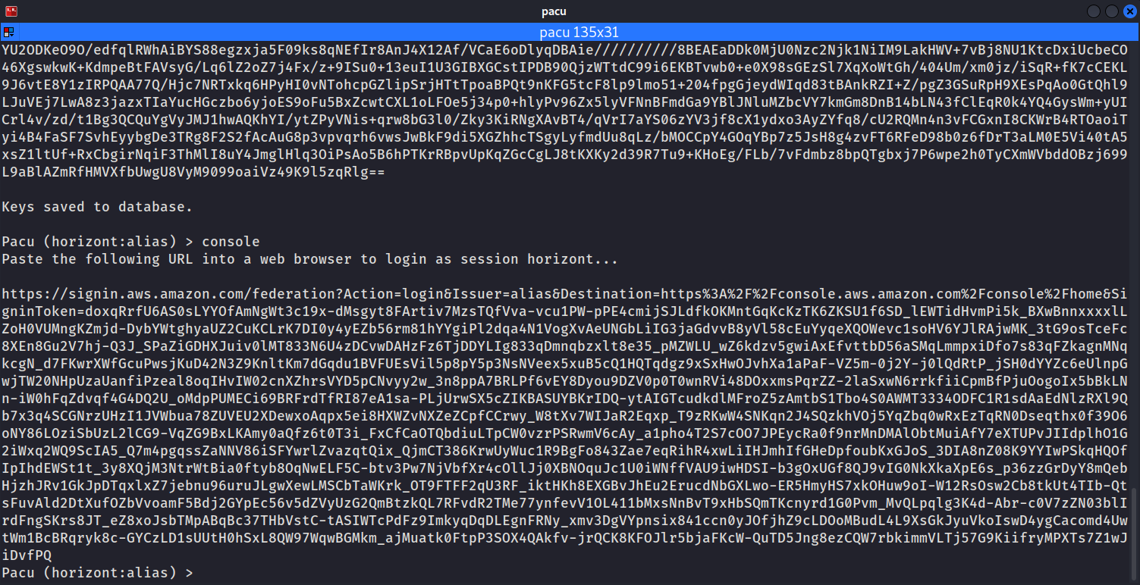
Pacu essentially generates a login link to the AWS console. You simply provide the keys obtained from the SSRF exploitation. By accessing the generated link, we gained access to the AWS console. Inside S3, we found the following file.
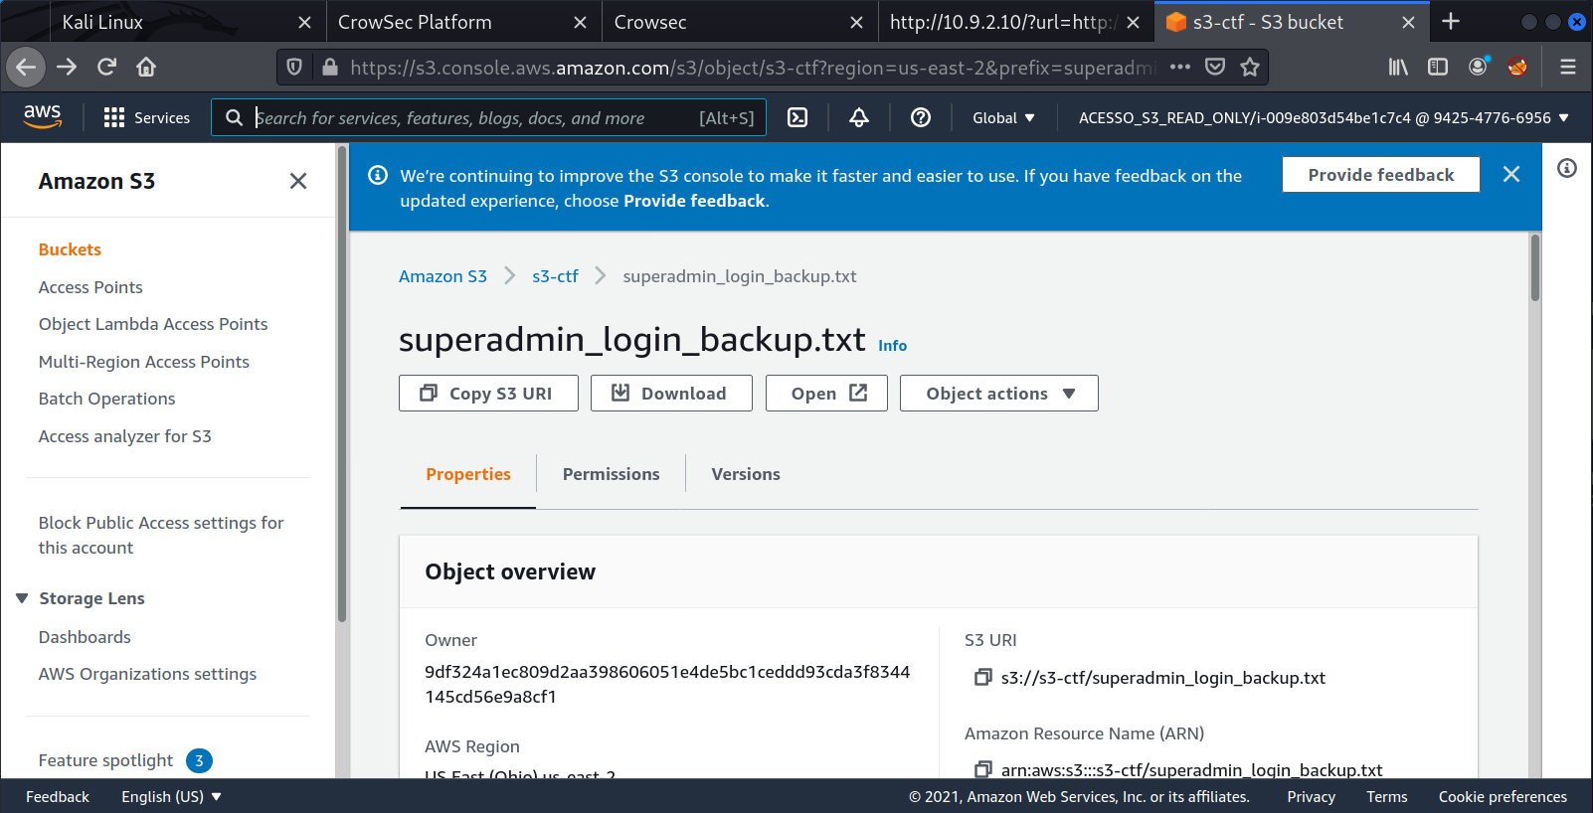
After downloading it to our machine, we were able to read its contents.
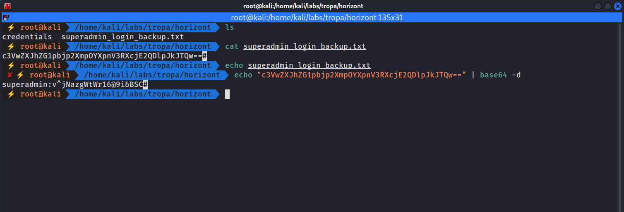
Using these credentials, we successfully logged into HorizontCMS running on port 8080.
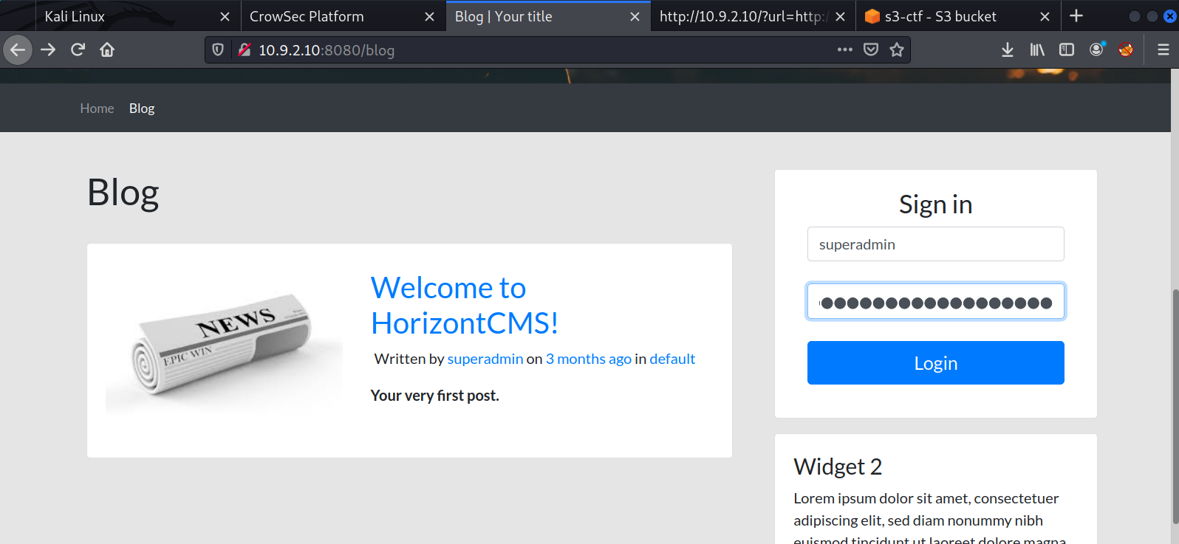

Inside HorizontCMS
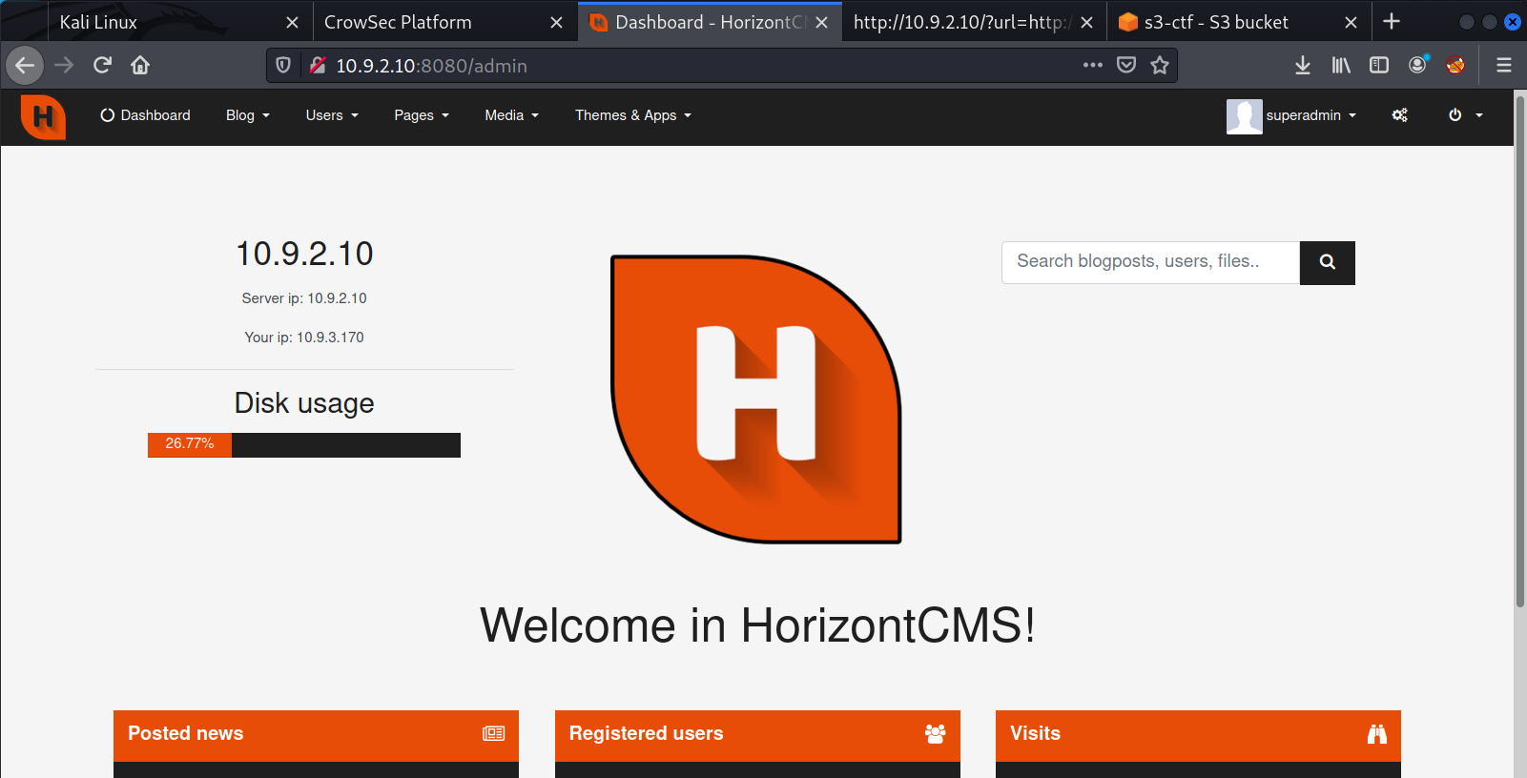
After logging into the application, we noticed that there is a Themes and Apps tab in this CMS, which could allow either shell upload or command injection. After extensive research about HorizontCMS, I found an article discussing a command injection vulnerability in a compatible plugin.
https://infosecwriteups.com/bughunt-authenticated-rce-found-in-horizontcms-part-1-malicious-plugins-72846f4ab6fe
The vulnerability occurs in the Google Maps plugin. When you add a new location in the plugin options, it displays a success message. However, that message is stored as PHP code, meaning we can inject malicious code into the file responsible for displaying that message.
First, we download the plugin from GitHub: https://github.com/ttimot24/HorizontCMS
After downloading the release, we extract it and navigate to:
GoogleMaps/resources/lang/en/

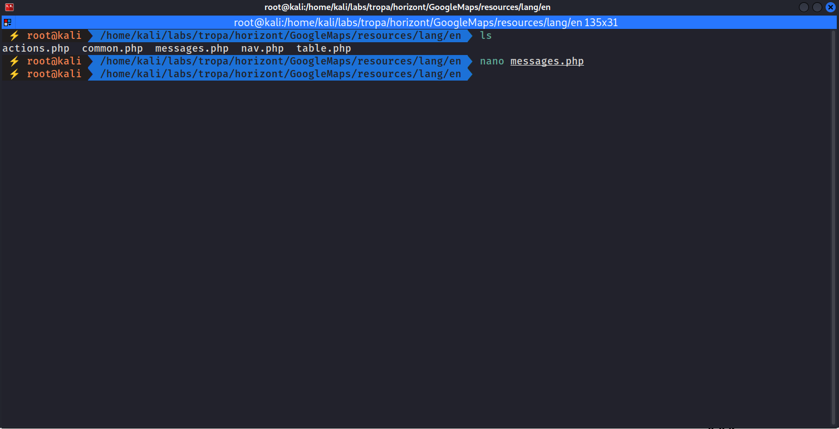

Editing messages.php:
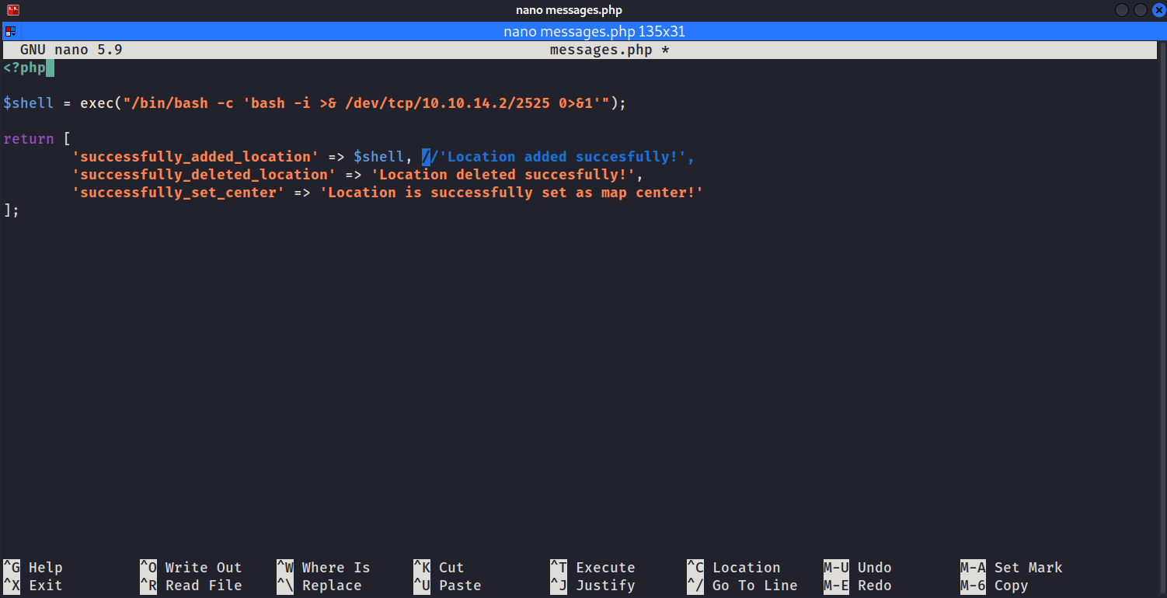
We inject our malicious PHP payload into messages.php. After inserting the malicious code, we compress the plugin again and upload it to HorizontCMS.
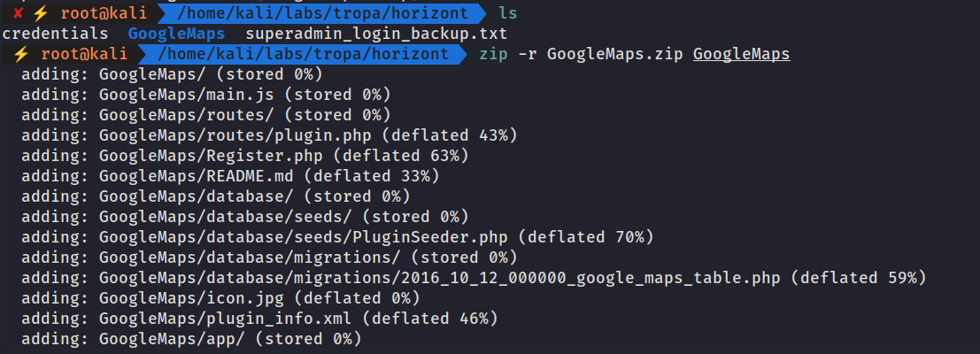
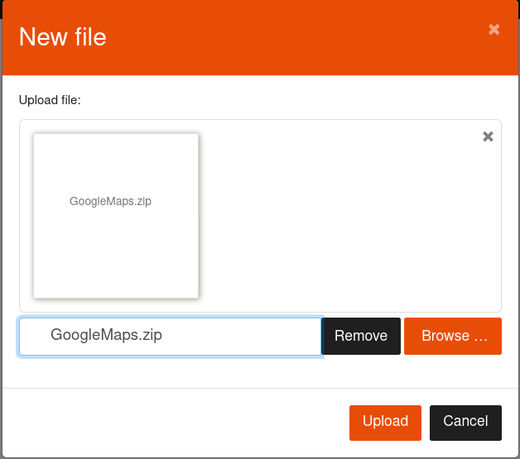
After uploading it, we add a new location to trigger the execution of our malicious code.
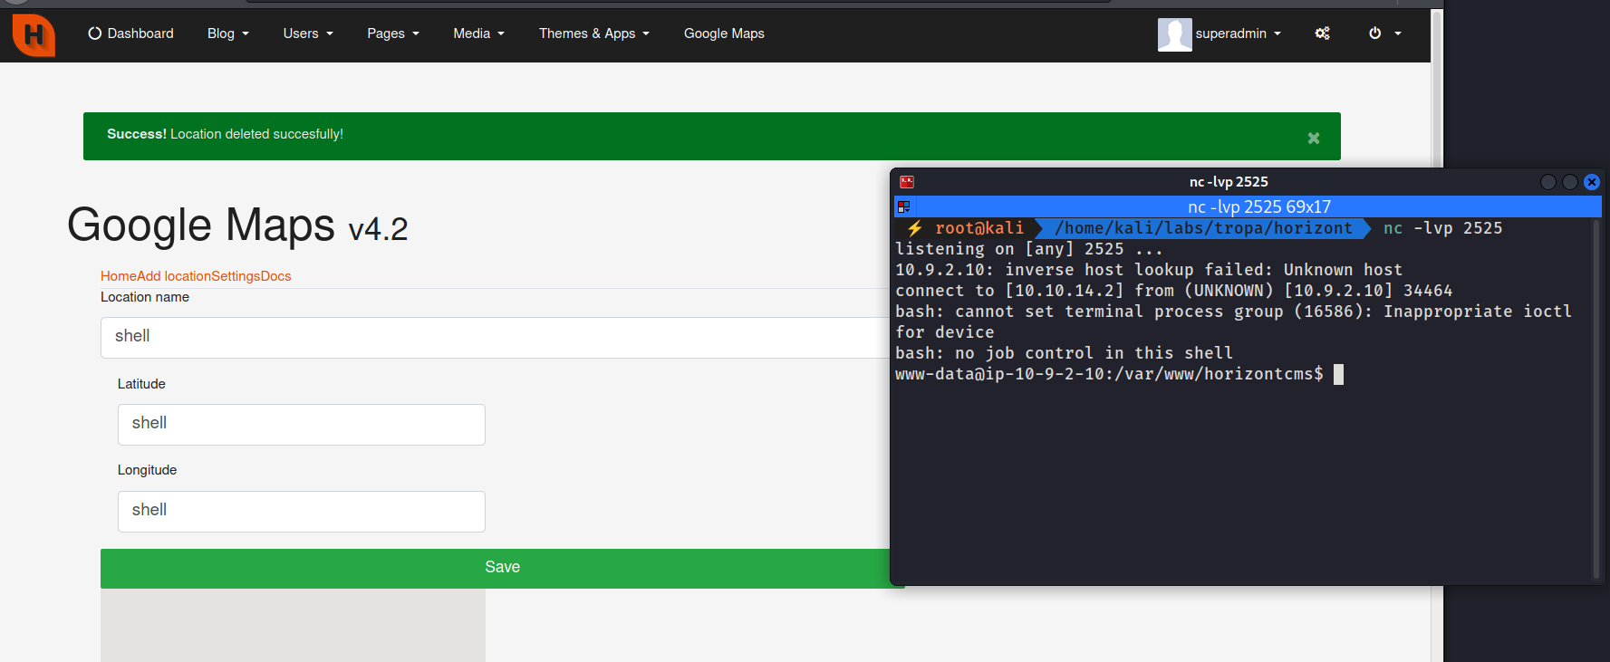
We can see that our command was executed, and we now have a shell on the system.
We can retrieve the root flag located at /flag.txt.

Privilege Escalation
Enumerating the SUID binaries on the machine, we observed that find was among the listed files:
find / -perm -4000 2>/dev/null
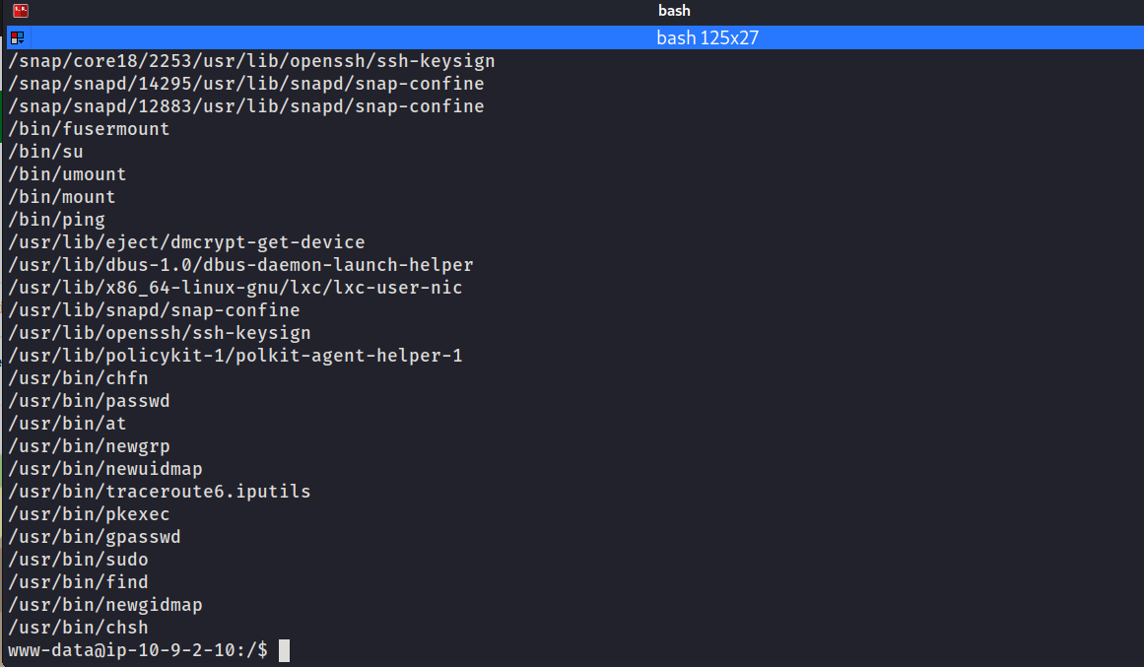
Since find has the SUID bit set, we can execute /bin/sh with root privileges:
find . -exec /bin/sh -p \; -quit
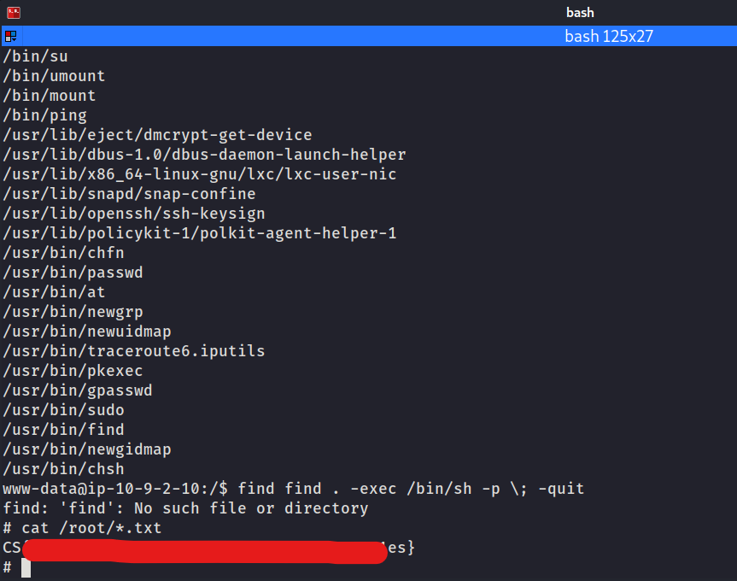
After spawning the privileged shell, we can read the final flag located in /root/root.txt.

